Credit cards

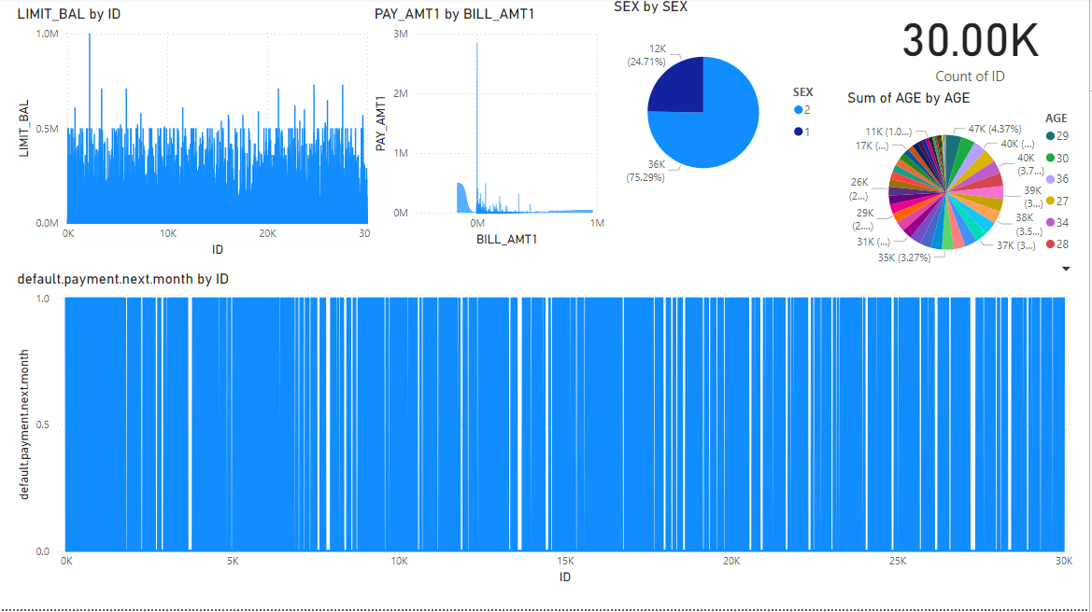

Downloaded credit card data and did visualization using power bi and involves customer data regarding how many people took the credit cards and their payback instalments and how much amount Is paid each time. it involves also the customer age and at which gender they belong to. it also represents their default payments of each member and their limited balance.